### 



**Prairie**

**View**

**A&M**

University

**INTER CONNECT-SOCIAL APPLICATION FOR ANDROID PHONES**

**NEELAM PATEL**

A Project

Submitted to the Department of Computer Science

In Partial Fulfillment of the Requirements for

The Degree of

MASTER OF SCIENCE

IN

COMPUTER SCIENCE

PRAIRIE VIEW A&M UNIVERSITY

COLLEGE OF ENGINEERING

PRAIRIE VIEW, TEXAS

December 2014

PRAIRIE VIEW, TEXAS

DECEMBER 2014

PRAIRIE VIEW A&M UNIVERSITY

COLLEGE OF ENGINEERING

PRAIRIE VIEW, TEXAS

**INTER CONNECT-SOCIAL APPLICATION FOR ANDROID PHONES**

A Project

Submitted to the Department of Computer Science

In Partial Fulfillment of the Requirements for

The Degree of

MASTER OF SCIENCE

IN

COMPUTER SCIENCE

Submitted By:

**NEELAM PATEL**

**Certificate of Approval:**

_____________________________ ____________________________

Kiranmai Bellam Sherri Frizell

Student Advisor Student Co-Advisor

Assistant Professor Associate Professor

Department of Computer Science Department of Computer Science

_____________________________

Lin Li

Graduate Program Coordinator

Associate Professor

Department of Computer Science

_____________________________

Yonggao Yang

Associate Professor

Department Head

Department of Computer Science

December 2014

ABSTRACT

Inter Connect-Social Application for Android Phones

(December 2014)

Neelam Patel

M.S., Prairie View A&M University

Student Advisor: Dr. Kiranmai Bellam

Social apps are a powerful tool to reach out to maximum number of people. Social apps are the only tool for user to introduce themselves to the whole community in such an easy way. A single profile with a photo will not only generate reactions from other user/people that have already created their profiles, but also attention gets from their interests. We are going to introduce and develop a system which brings users across various corners together, and lets them connect. The main goal of this project is the development of an Android-based application to provide to help stranger connect with each other based on their origin, interest, belief, and etc. So stranger can become friends and hangout together. The Inter Connect-Social application provides user a means to share their interest. After downloading the app, the application requires authentication to register in to the app. User can login in order to start using the app. Once the user login, he/she is given the option to search the people on basic of country, state and city, and to view information about the user he/she will be friends with, and user can select their own interest, and user can create event and ask other user to attend. The application front-end is built on technologies including the Eclipse IDE, Android SDK, XML, and JAVA, while the back-end utilizes SQL Server database.

Table of Contents

ABSTRACT iii

Table of Contents iv

List of Figures vii

List of Tables viii

SECTION 1 1

INTRODUCTION 1

1.1 Purpose 2

1.2 Scope 2

1.2.1 In Scope 2

1.3 Definitions, Acronyms, and Abbreviations 4

1.3.1 Acronyms and Abbreviations 4

1.3.2 Definitions 5

1.4 Overview 5

SECTION 2 7

DEVELOPMENT ENVIRONMENT 7

2.1 Android Architecture 7

SECTION 3 12

PROJECT GOALS & OBJECTIVES 12

3.1 Goal 12

3.2 Objectives 12

SECTION 4 13

SYSTEM DESCRIPTION 13

4.1 Product Perspective 13

4.2 Product Features 13

4.3 System Structure of Inter Connect-Social Application 14

4.3.1 SQL Server Introduction: 15

4.4 Assumptions and Dependencies 16

4.5 Project Constraints 16

SECTION 5 18

REQUIREMENT MODELING 18

5.1 Functional Requirement 18

5.2 Hardware Requirement 19

5.3 Software Requirement 19

5. 4 Tools Used 19

SECTION 6 20

FUNCTIONAL MODELING 20

6.1 Use Cases 20

6.1.1 Use Case 1: User Sign up/Login into the Application. 22

6.1.2 Use Case 2: View Profile, And Edit Profile. 24

6.1.3 Use Case 3: Edit Interest 26

6.1.4 Use Case 4: Search for people by country, state and city. 27

6.1.5 Use Case 5: Friend Circle. 29

6.1.6 Use Case 6: Post and Search Forum. 31

6.1.7 Use Case 7: Create Event. 33

6.2 Activity Diagrams 34

6.2.1 Activity Diagram: Login or sign up by user 35

6.2.2 Activity Diagram: To view, edit/update profile 36

6.2.3 Activity Diagram: To Search list Of People 37

6.2.4 Activity Diagram: Friend Circle 38

6.2.5 Activity Diagram: Forum 39

6.3 Swim-lane Diagrams: 41

6.3.1 Swim-lane Diagram: Login by user 41

6.3.2 Swim-lane Diagram: To View Profile 43

6.3.3 Swim-lane Diagram: Search list of people 44

SECTION 7 45

CLASS-BASED MODELING 45

7.1 Analysis Classes 45

7.2 Class Diagram 45

7.3 Class Table 47

SECTION 8 56

SEQUENCE DIAGRAM 56

8.1 Sign Up and Log in 56

SECTION 9 57

DATA DESIGN 57

9.1 Data flow Diagrams 57

9.2 Database Diagram 58

SECTION 10 60

SCREEN SHOTS AND CODE SNIPPET 60

1. Login Screen: 60

2. Home Screen: 61

3. View Profile: 62

4. Search list of people: 65

5. Detail Information of User screen: 66

6. Friend Circle Screen 67

7. Post Forum screen 68

8. View Forum screen 69

9. Create Event: 70

10. View Event: 71

SECTION 11 73

TESTING 73

10.1 Classes of Tests 73

10.2 Expected software response 74

10.3 Performance Bounds 74

SECTION 12 75

CONCLUSION & FUTURE WORK 75

SECTION 13 76

REFERENCES 76

# List of Figures

FIGURE PAGE

Figure 1: Architecture diagram of Android Application Framework version 2.6 [1] 8

Figure 2: Linux Kernel 9

Figure 3: Libraries 9

Figure 4: Android Runtime 10

Figure 5: Application Framework 10

Figure 6: Applications 11

Figure 7: System Architecture of inter connect-social application 14

Figure 8: SQL Server Architecture [4] 15

Figure 9: Use Case Diagrams for Inter Connect-Social Application 21

Figure 10: Activity Diagram: Login or sign up by user 35

Figure 11: Activity Diagram: To view, edit/update profile 36

Figure 12: Activity Diagram: To Search list Of People 37

Figure 13: Activity Diagram: Friend Circle 38

Figure 14: Activity Diagram: Forum 39

Figure 15: Activity Diagram: Event 40

Figure 16: Swim-lane Diagram: Login by user 42

Figure 17: Swim-lane Diagram: To View Profile 43

Figure 18: Swim-lane Diagram: Search list of people 44

Figure 19: Class Diagram with Attributes and Operations 46

Figure 20: Sequence Diagram: Sign Up and Login 56

Figure 21: Context (Level 0) Diagram: Login and Registration by user 57

Figure 22: Level 1 Data Flow Diagram: Login and Registration by User 58

Figure 23: Database Diagram of Inter Connect-Social Application 59

# List of Tables

TABLE PAGE

Table 1: Table of Acronyms and Abbreviations 4

Table 2: Table of Definitions 5

Table 3: Table of Use Cases 20

Table 4: Table of Classes 47

# SECTION 1

# INTRODUCTION

Now a day, mobile phone is used 24 by 7 mostly by everyone. A Smartphone installed with Android OS can be gives us with a variety of applications to provide a global connectivity. Smartphone's installed with Android OS just require an app to get connected with stranger. They were designed to enhance flexibility, usability, and functionality of the communication system. The Smartphone's are the major resources of the present system for speedy and smart activities. Android architecture consists of Linux kernels, libraries and APIs written in C and inbuilt java compatible libraries for developers and an inbuilt server, a free type of software and open source license, aspect that makes it very attractive among developers. Thus we are going to use this Android architecture to develop social application.

People face many problems, when they are not in hometown. Relocating to another country can be a daunting prospect; particularly if you don't speak the language of the current country. In that case people feel homesickness. People always wonder to connect to their won origin people and love hangout with them.

The app is especially useful to members, who are living away from his /her hometown country and away from friends and very alone in current country. People cannot make friends easily.

To address this problem this project proposes an android app “Inter Connect-Social” app helps them to connect to people who have same origin, interest, belief, and etc.

## Purpose

The purpose of designing inter connect-social application is to provide a mobile application to the people. The inter connect-social application enable its users with a way to connect and share interest. They can search people from their origin, with the same interest and create event and hangout together.

The app is primarily designed for the people who are away from hometown. For security authentication of the email id is done before registration. The entire users in the database are authenticated.

Anyone can use the application. People who are going to register into app have to all information and select the interests. On basis of interest user can search people. Such as, if a user looking for particular country, state and city, the application will show the list of people on these search criteria. Also, user can search the forum and add comment to that post.

Thus, the application helps in connecting people with each other. Application centralizes all information using the SQL Server database to store and retrieve data in to the application.

This document describes the detail features of application, as well as an application user manual document for the client.

## Scope

This section describes the features which are in the scope of developed application.

### In Scope

* View main screen with,
  + SignUp Button
  + Login Button
* Users can sign up and then login to the application.
* Users can sign up to the application by providing valid email ID
* Application sends a unique verification code to the entered email ID
* Once the user gets the code, the user has to enter that code. The application will automatically verify the given code information. If the code is correct, the application will allow the user to next screen otherwise it will show an error message.
* On the next screen user has to enter personal information such as: full name, last name, password, DOB, gender, hometown address, current addressand profile picture. All information would save into database.
* User can login to the application with email ID and password.
* Users can view, edit, and update their profile.
* Users can browse and insert a profile picture into their profile.
* User can take a picture from the camera and insert that picture into the application.
* Users can search people by clicking on “Search Button” and can select basic search or advance search.
* On Basic search/Advance search User has to select search criteria, enter information on basis of criteria, User will get list of people from the database according to their search.
* Users can view other people interest before sending them friend request.
* Users can check friend circle by clicking on “Friend Circle Button” and can select “Accepted button”, “Waiting for my response button”, and “Waiting for their response button”.
* Accepted shows the list of people who accepted the friend request and become friends.
* Waiting for my response shows the list of people who send the friend request to the user.
* Waiting for their response shows the list of people who user sends the friend request.
* Users can post, view and search forum on clicking on “Forum button”.
* In view forum user can share their won comment on particular post.
* User can delete comment or forum post, by clicking on “delete image”.
* User can create event by clicking on “Create Event Button”.
* Users can attend event by clicking on the “View Event” button and selecting yes from the dropdown list.

## Definitions, Acronyms, and Abbreviations

This section describes the terms required to interpret this document. The acronyms and abbreviations used throughout this document are listed below. The definitions describe the exact meaning of the word

### Acronyms and Abbreviations

Table 1: Table of Acronyms and Abbreviations

|  |  |
| --- | --- |
| IDE | Integrated Development Environment |
| SDK | Software Development Kit |
| GUI | Graphical User Interface |
| VMs | Virtual Machines |
| DVM | Dalvik Virtual Machine |
| DM | Device Manager |

### Definitions

Table 2: Table of Definitions

|  |  |
| --- | --- |
| User | The person who has been register in to application and using the application. |
| Wi-Fi | A feature available for smart/3G/4G mobile phones having a Wi-Fi  Adapter. |
| Android | The smartphone operating system with Linux kernel inside, which is  Developed by Google. |

## Overview

The rest of the document is organized as follows: Section 2 provides brief information of development environment of the application. Section 3 describes the goal and objectives of the project. Section 4 gives an overall description of the Android application development, product features, system structure of the inter connect-social application, and some assumptions and dependencies that are implicit. System software and hardware specifications are listed in section 5. Section 6 shows the use case template; use case diagram, activity diagrams and swim lane diagram. Section 7 describes the analysis of the system using classes and database. Section 8 shows sequence diagram. Section 9 explains the data flow inside inter connect-social application. Screen shots and code snippets are shown in section 10 shows. Section 11 describes various testing methods. At last the document shows conclusion, future work and references used for application development in section 12, and 13 respectively.

# SECTION 2

# DEVELOPMENT ENVIRONMENT

**Android:**

Android is a Linux based operating system for mobile devices which includes Linux kernel, middleware and other key applications. The Android SDK provides APIs and tools to develop applications for the Android platform using JAVA programming language.

## Android Architecture

* **What is an Android?**

“Android is an open source and Linux-based mobile operating system that combines and builds many different open source projects”.

Android applications are usually developed in the Java language using the Android Software Development Kit. Once applications developed, Android applications can be packaged easily and sold out either through a store such as Google Play.

* **What is Architecture?**

“It is an arrangement of the various devices in a complete computer system or network”. This internal organization of a computer's components is organized with particular reference so that it transmits a data through a system.

The figure below shows the major components of the Android operating system.

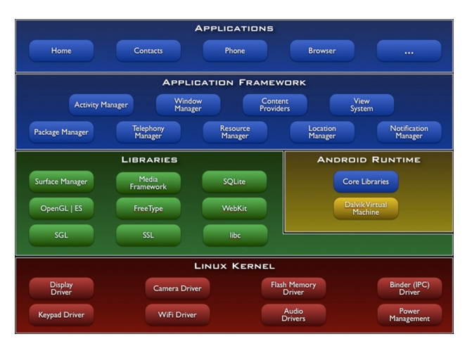

Figure 1: Architecture diagram of Android Application Framework version 2.6 [1]

Android platform are divided into five primary layers namely [1]:-

* **Linux Kernel:**

The kernel system service provided by Android inner nuclear layer is based on Linux 2.6 kernel; Operations like internal storage, process management, internet protocol, bottom-drive and other core service are all based on Linux kernel [2].

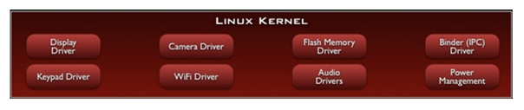

Figure 2: Linux Kernel

* **Libraries:**

Android system library is support the application framework; it is also an important link connecting between application framework and Linux Kernel. This system library is developed in C or C++ language. These libraries can also be utilized by the different components in the Android system. They provide service for the developers through the application framework [2].

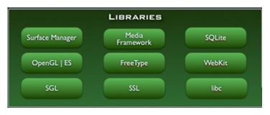

Figure 3: Libraries

* Android Runtime:

Android Runtime is consisted of a Java Core Library and Dalvik virtual machine. The Core Library provides Java core library with most functions. Dalvik virtual machine is register virtual machine and makes some specific improvements for mobile device [2].

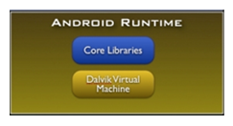

Figure 4: Android Runtime

* **Application Framework:**

The developer is allowed to access all the API framework of the core programs. The application framework simplifies the reuse of its components. Any other app can release its functional components and all other apps can access and use this component (but have to follow the security of the framework). Same as the users can be able to substitute the program components with this reuse mechanism [2].

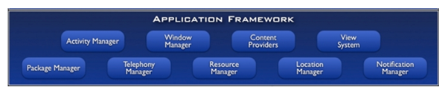

Figure 5: Application Framework

* **Applications:**

Android app will be shipped with a set of core applications including client, SMS program, calendar, maps, browser, contacts, and others. All these application programs are developed in Java [2].

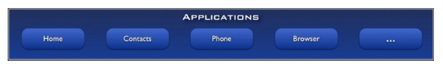

Figure 6: Applications

# SECTION 3

# PROJECT GOALS & OBJECTIVES

## Goal

The goal of this project is to design and implement the Inter Connect-Social application for Android Smart Phones.

## Objectives

* Install JAVA SDK (Software Development Kit) on development machine.
* Install Eclipse IDE on development machine.
* Install Android SDK and AVD (Android Virtual Device) on development machine.
* Understand the Android GUI (Graphical User Interface) and features of Android application.
* Understand JAVA API (Application Program Interface).
* Design and Implementation of Inter Connect-Social application (Screens).
* Design and Implementation Business Logic for the application.
* Design, Implementation and Understanding of Data Hierarchy.
* Install SQL Server (Windows 32 bit)

# SECTION 4

# SYSTEM DESCRIPTION

## Product Perspective

This application can be installed on any smart phone which has the Android operating system. Users can easily open this application by clicking on the application icon. This application displays two access types: login for the registered user and signup for new member. As per the user’s access type, the application displays its dynamic layout. The application uses the SQL Server database to store information

## Product Features

The application provides plenty of valuable features to its user.

* Application allows access to the register user and new member.
* Users can login and signup to the application by providing email ID, password and personal information. Hence, the application new member does not have any access to the application unless they sign up into the application.
* For signup, new users need to enter email ID. Once user submits email ID, system sends verification code to email ID which is enter by new user.
* Register Users can view, edit, and update profile.
* Register Users can browse and insert a profile picture into profile from gallery or from camera.
* Register Users can receive can search people by country, state, city and interest.
* Register Users can view forum and event.
* Register Users can create event and post private or public.
* Register users can join event which has been created by other user.

## System Structure of Inter Connect-Social Application

The System architecture of inter connect-social application for android phone is shown in figure 7. It describes all the major tasks and functionalities of an app.

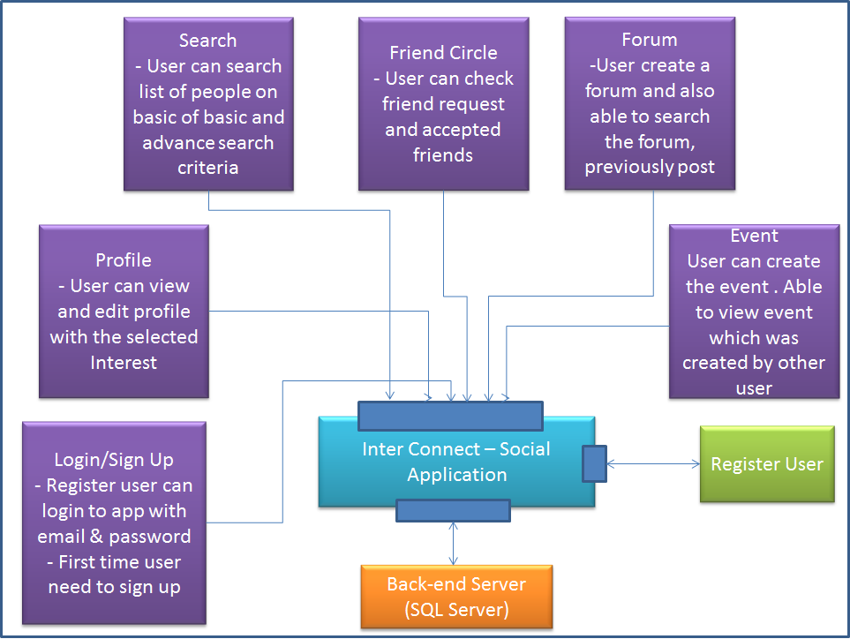

Figure 7: System Architecture of inter connect-social application

As shown in Figure 7 the application has two essential components that are, Client (app), and SQL server (back-end server). The application interacts directly with the SQL Server. All violet colored boxed are shown that are the functionality of the inter connect-social application.

### SQL Server Introduction:

A client/server database is a database that is stored in one computer named a server and other computers named clients connect to the server to access and use the database.

Microsoft SQL Server is an application used to create computer databases for the Microsoft Windows family of server operating systems. Microsoft SQL Server provides an environment used to generate databases that can be accessed from workstations, the Internet, or other media such as a personal digital assistant (PDA) [3].

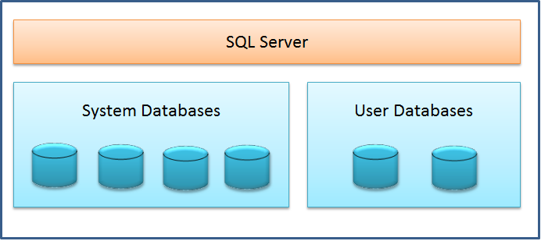

Figure 8: SQL Server Architecture [4]

**System Databases**

Systems have four system databases [5]:

* **master**

The master database records all of the system level information for a SQL Server system. It records all login accounts and all system configuration settings.

* **Tempdb**

Tempdb holds all temporary tables and temporary stored procedures.

* **model**

The model database is used as the template for all databases created on a system.

* **Msdb**

The msdb database is used by SQL Server Agent for scheduling alerts and jobs, and recording operators.

## Assumptions and Dependencies

* User having access to Smartphone with Android as the operating system.
* Smartphone has internet access either using Wi-Fi or 3G data.
* Smartphone has touch screen input.
* User has access to its respective application store to download and install the application
* Application requires SQL Server database, to store and retrieve information.

## Project Constraints

* Smartphone needs to have Internet access to use this application. In case of unavailability of internet, some part of application such as view profile, search people, post forum, will not work properly.
* All data entered from user input is assumed to be true. There is no verification method implemented to check user’s input such as hometown country and current country. Hence application will auto check email address format.
* Application can only be used with Smartphone having Android operating system.
* Only users who have an account in the inter connect-social app can use this application.

# SECTION 5

# REQUIREMENT MODELING

## Functional Requirement

Functional requirements define specific functionality that defines what a system is supposed to accomplish. A function is described as a set of inputs, the behavior, and outputs.

Following are some functional requirements:

* Application able to installable only on Android devices.
* Application verifies the verification code sent by system to the user, before signup
* Application auto checks email format.
* Application allows user to insert a picture into the profile, from camera and gallery.
* Application allows user to edit/view/update profile.
* Application allows user to search people by country, state, city and interest.
* Application allows user to see information of the person who send the friend request.
* Application allows user to post the forum and posted forum can be view and search.
* Application deletes if user want to delete the forum or comment.
* Application allows user to create and attend the event.
* Application filters result of event on the basis of date.
* Application allows user to logout before exit from application.

## Hardware Requirement

* Android smartphone
* Memory Space: 4 GB of disk space, 4 GB of RAM for development machine
* Connector: USB cable to export the app from development machine to Android device

## Software Requirement

* Eclipse JAVA IDE EE for web developers.
* Android SDK and AVD installed on development machine.
* .Java (JDK) 1.6
* Android Plug-in
* SQL Server for database

## 5. 4 Tools Used

* SQL Server 2014 Management Studio
* Visual Paradigm
* Eclipse

# SECTION 6

# FUNCTIONAL MODELING

## Use Cases

In Inter Connect-Social application, there is only one actor, User. The primary use case associated with this application is shown below. Figure 9 shows use case diagram for Inter Connect-Social application

Table 3: Table of Use Cases

|  |  |
| --- | --- |
| UC-01 | Sign up/Login into the Application. |
| UC-02 | View Profile, And Edit Profile. |
| UC-03 | Edit Interest |
| UC-04 | Search for people by country, state and city. |
| UC-05 | See Friend Circle. |
| UC-06 | Post and Search Forum |
| UC-07 | Create Event |

A Use Case Diagram shown in Figure 9 is the list of steps, which typically defines interaction between an actor (User) and system, to achieve a goal.

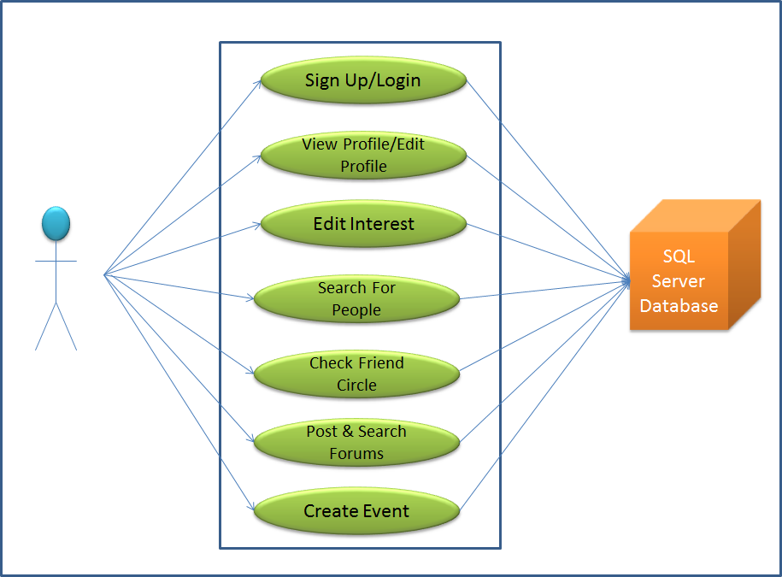

Figure 9: Use Case Diagrams for Inter Connect-Social Application

The rest of the sections and sub-sections are describes as follows, Section 6.2 shows activity diagrams. Activity diagram represents flow of interaction within specific scenario. Section 6.3 shows Swim-lane diagrams. Swim-lane diagram is a variation of the activity diagram and represents the flow of activities which is described by the use case and at the same time indicate which actor has responsibility for the action described by an activity circle. Section 7 describes class based modelling and sequence diagram will be explained in section 8. Section 9 describes data flow diagrams. Screen shots and code snipes are listed in section 10. And finally Section 11, 12 and 13 explains Testing, conclusion and Future Work respectively.

### Use Case 1: User Sign up/Login into the Application.

|  |  |  |  |
| --- | --- | --- | --- |
| Use Case ID: | UC-01 | | |
| Use Case Name: | Sign up/Login into the Application. | | |
| Created By: | Neelam Patel | Last Updated By: | Neelam Patel |
| Date Created: | Nov 01, 2014 | Date Last Updated: | Nov 01, 2014 |
| Primary Actors: | User (Member) | | |
| Description: | This use-case is used when user wants to signup first time to the app, or member wants to login using their username and password. | | |
| Trigger: | When a user accesses the Home button from of app. | | |
| Preconditions: | User requires entering required field shown on the screen. | | |
| Post conditions: | Record will be saved into database and application will allow access to the user. | | |
| Scenario: | 1. First time user clicks on “Sign Up” button from Main screen of the application. 2. User enters the Email ID and click on “Verify Email ID”. 3. Once user press the “Verify Email ID” button, system pops up small window.    * 1. The system will automatically sends an email to the user and shows message that, “Verification code sent to your mail id”. 4. User needs to enter a verification code sent in email, in the text box and press “Submit”. 5. Once user enters given verification code, system verifies the given information and displays appropriate message to the user.    * 1. If given Verification Code is correct, then system shows a message, “Your Email is verified”, and user needs to press “Ok”. Once user presses “Ok”, user will be on next screen      2. If given Verification Code is incorrect, then system will prompt a message, “incorrect verification code”, and he/she will have to enter code again. 6. User enters the personal information such as First Name, Last Name, Password, DOB, Gender, Home town Address, Current Address and select profile picture. 7. User presses ‘Save’ button to save the data into the database. 8. User Account is created and User comes to Home Screen. 9. If User has already created account, then user can login to system by directly entering ‘Email and ‘Password’, and press ‘Login’ button. 10. System will check whether Email and Password is correct. 11. After Successful login user will come to the home screen, to view profile and all the other activities. | | |
| Exceptions: | If the user does not have valid email id for account. | | |
| Priority: | Moderate priority; To be implemented after basic functions. | | |
| Frequency of Use: | High | | |
| Channel to Actor: | Via Android Smart Phone. | | |
| Special Requirements: | Database Connection. | | |

### Use Case 2: View Profile, And Edit Profile.

|  |  |  |  |
| --- | --- | --- | --- |
| Use Case ID: | UC-02 | | |
| Use Case Name: | View Profile, And Edit Profile. | | |
| Created By: | Neelam Patel | Last Updated By: | Neelam Pate; |
| Date Created: | Oct 05, 2014 | Date Last Updated: | Nov 03, 2014 |
| Primary Actors: | User (Register Member) | | |
| Description: | This use-case is used when user wants to edit/update his/her profile, view profile. | | |
| Trigger: | When user Click on the ‘Profile’ from Home Screen, this use-case will trigger. | | |
| Preconditions: | User needs to Login to view profile, edit/update profile or to change a profile picture. | | |
| Post conditions: | User can successfully view profile, edit/update profile, browse/insert picture into the profile. | | |
| Scenario: | 1. User needs to complete UC-01 successfully. 2. To View Profile:   From Home Screen, user needs to click on “Profile” button.  Once user clicks on “Profile” button, again user need to click on ‘View Profile’, then user can view the profile details such as profile picture, Full name, Hometown Address and Current Address.   1. To Edit/Update profile: 2. On View profile screen, User clicks on ‘Edit’ button. 3. Once user clicks on edit profile, application will allow you to edit every field. 4. After editing required fields, user clicks on ‘Update’ button. 5. To Browse/Insert a profile picture: 6. On View profile screen, Member clicks on ‘Browse Photo’ button. 7. Once member clicks on button, application shows two options to how to browse/insert a picture, i.e. ‘Take from camera’ and ‘Select from Gallery’.    1. If user selects option “Take from camera”, then system opens camera. User takes a picture, crop it if he/she wants and set that picture as profile picture.    2. If user selects option, “Select from Gallery”, then system opens phone gallery to select a picture. Once user selects a picture, system allows user to crop it and insert it.    3. After inserting photo, user clicks on ‘Update’ button 8. To check interest: 9. On View profile screen, User clicks on ‘Your Interest’ button. 10. Once user clicks on, application show user selected interest according to the category in drop down list. 11. After clicking ‘Update’ user comes to the home screen. From home screen user can logout from the application by press back button. | | |
| Exceptions: | If the member does not login into the application. | | |
| Priority: | High Priority; To be implemented as basic functions. | | |
| Frequency of Use: | High | | |
| Channel to Actor: | Via Android Smart Phone. | | |
| Special Requirements: | Database Connection, Internet. | | |

### Use Case 3: Edit Interest

|  |  |  |  |
| --- | --- | --- | --- |
| Use Case ID: | UC-03 | | |
| Use Case Name: | Edit Interest | | |
| Created By: | Neelam Patel | Last Updated By: | Neelam Patel |
| Date Created: | Oct 01, 2014 | Date Last Updated: | Nov 05, 2014 |
| Primary Actors: | User ( Register Member) | | |
| Description: | This use-case is used when user wants to edit his/her Interests. | | |
| Trigger: | When user Click on the ‘Profile’ from Home Screen, this use-case will trigger. | | |
| Preconditions: | User needs to Login to edit Interest | | |
| Post conditions: | User can successfully edit and can view selected Interests. | | |
| Scenario: | 1. User needs to complete UC-01 successfully. 2. To Edit Interest:    * + - 1. From Home Screen, user needs to click on “Profile” button.          2. Once user clicks on “Profile” button, again user need to click on ‘Edit Profile’, then user can select different kind of Interests.          3. When click on particular Interest category, list of interest is shown with checkboxes. Check the checkboxes and click on ‘Save’ button. All information is saved in to database. 3. To check interest:   On View profile screen, User clicks on ‘Your Interest’ button.  Once user clicks on, application show user selected interest according to the category in drop down list.   1. From home screen user can logout from the application by press back button. | | |
| Exceptions: | If the user does not have internet access to get Interest from database. | | |
| Priority: | High priority; To be implemented as basic functions. | | |
| Frequency of Use: | High | | |
| Channel to Actor: | Via Android Smart Phone. | | |
| Special Requirements: | Database Connection, Internet. | | |

### Use Case 4: Search for people by country, state and city.

|  |  |  |  |
| --- | --- | --- | --- |
| Use Case ID: | UC-04 | | |
| Use Case Name: | Search for people by country, state and city. | | |
| Created By: | Neelam Patel | Last Updated By: | Neelam Patel |
| Date Created: | Oct 05, 2014 | Date Last Updated: | Nov 05, 2014 |
| Primary Actors: | User ( Register Member) | | |
| Description: | This use-case is used when user wants search list of people. | | |
| Trigger: | When user access “Search” from Home Screen, then this use-case will trigger. | | |
| Preconditions: | User required to Login to the application. | | |
| Post conditions: | Results will be displayed to uses from application database. | | |
| Scenario: | 1. User needs to complete UC-01 successfully. 2. From Main menu user clicks on “Search” button. 3. Once user clicks on “Search” button, user will be on search screen,   He/she can select,   1. “Basic Search” button 2. “Advance Search” button 3. User click “Basic Search” button.    1. User need to select search criteria and check the checkboxes of hometown and current location.    2. User click on ‘Submit’ button.    3. User must enter proper information of hometown and current location.    4. User can see list of people on selection of search criteria from the database.    5. Can send friend request to the people listed in the list. 4. User click “Advance Search” button.    1. User need to select search criteria and check the checkboxes of hometown and current location.    2. User click on ‘Submit’ button.    3. User must enter proper information of hometown and current location.    4. User click on “Continue Search” button.    5. User can see different interest category button, he/she can select any one of them and check the checkbox one by one category.    6. User click on “Show list of People” button.    7. User can see list of people on selection of search criteria from the database.    8. Can send friend request to the people listed in the list. 5. After viewing list of people, user can press “Home” button, then user will come to the Home screen. 6. From the Home screen user can logout. | | |
| Exceptions: | If the user does not sign in to app. | | |
| Priority: | High; To be implemented as basic functions. | | |
| Frequency of Use: | Moderate | | |
| Channel to Actor: | Via Android Smart Phone. | | |
| Special Requirements: | Database Connection. | | |

### Use Case 5: Friend Circle.

|  |  |  |  |
| --- | --- | --- | --- |
| Use Case ID: | UC-05 | | |
| Use Case Name: | Friend Circle. | | |
| Created By: | Neelam Patel | Last Updated By: | Neelam Patel |
| Date Created: | Nov 07, 2014 | Date Last Updated: | Nov 08, 2014 |
| Primary Actors: | User (Register Member) | | |
| Description: | This use-case is used when a user wants to view Friend circle i.e. Peoples who are waiting for my response, waiting for their response and accepted. | | |
| Trigger: | When member accesses “Friend Circle” from Home screen, this use-case will trigger. | | |
| Preconditions: | User requires login successfully, in order to access Friend Circle from Home screen. | | |
| Post conditions: | Application shows the list of people to whom user send the friend request and the request user got from other users and the list of friend. | | |
| Scenario: | 1. User needs to complete UC-01 successfully. 2. From Home screen user clicks on “Friend Circle” button. 3. Once user clicks on “Friend Circle” button, user will be on Friend circle screen, He/she can select,    * + - 1. “Accepted Request” button          2. “Waiting For My Response” button          3. “Waiting For Their Response” button 4. User click on Accepted Request button and list of friends are shown. Data comes from the database. 5. User click on Waiting for My Response button.   List of people is shown from the database.  User click one of the person, user can see details information of the user.  User can select accept button or reject button.  If user select accept then user is shown in accepted request.  If he/she select reject the user is rejected the friend request.   1. User click on Waiting for Their Response button and list of friends to whom user has sends the friend request are shown. Data comes from the database. 2. If user wants to come back to the Home screen, he/she can press “Home” button. 3. From the home screen user can logout by pressing “Back” button of the phone. | | |
| Exceptions: | If user hasn’t found data from the database. | | |
| Priority: | Moderate priority; To be implemented as independent functions. | | |
| Frequency of Use: | High | | |
| Channel to Actor: | Via Android Smart Phone. | | |
| Special Requirements: | Database Connection, Internet | | |

### Use Case 6: Post and Search Forum.

|  |  |  |  |
| --- | --- | --- | --- |
| Use Case ID: | UC-06 | | |
| Use Case Name: | Post and Search Forum | | |
| Created By: | Neelam Patel | Last Updated By: | Neelam Patel |
| Date Created: | Oct 07, 2014 | Date Last Updated: | Nov 03, 2014 |
| Primary Actors: | User (Register Member) | | |
| Description: | This use-case is used when a member wants to view, search and post Forum Requested. | | |
| Trigger: | When member accesses “Forum” from Home Screen, this use-case will trigger. | | |
| Preconditions: | User requires login successfully | | |
| Post conditions: | Application shows the list of forum, which was previously posted. | | |
| Scenario: | 1. User needs to complete UC-01 successfully. 2. From Home screen user clicks on “Forum” button. 3. Once user clicks on “Forum” button, application displays three other button, from which user can select any one. The button are , 4. “View Topic” button. 5. “Post Topic” button. 6. “Search Topic” button. 7. If user click on “View Topic” button.    1. User get list of the topic which was previously posted by the other user.    2. User can give comment on any topic by clicking on the topic.    3. User click on “Write Your Comment” button, to write the comment. 8. If user click on “Post Topic” button.    1. User enters the subject and body of the topic and click on the “Post” button.    2. When user click on post button, Forum screen is displayed.    3. Post is stored in to database. 9. If user click on “Search Topic” button.    * + - 1. User enters the topic to search and click on the “Search” button.          2. User get list of the comment of that topic which was previously posted by the other user.    1. User can give comment on that topic by clicking on the button.    2. User click on “Write Your Comment” button, to write the comment. 10. If user wants to come back to the Home Screen, he/she can press “Home” button. 11. From the home screen user can logout by pressing “Back” button of the phone. | | |
| Exceptions: | If user hasn’t connected to the database | | |
| Priority: | Moderate priority; To be implemented as independent functions. | | |
| Frequency of Use: | Moderate | | |
| Channel to Actor: | Via Android Smart Phone. | | |
| Special Requirements: | Database Connection. | | |

### Use Case 7: Create Event.

|  |  |  |  |
| --- | --- | --- | --- |
| Use Case ID: | UC-07 | | |
| Use Case Name: | Create Event. | | |
| Created By: | Neelam Patel | Last Updated By: | Neelam Patel |
| Date Created: | Oct 07, 2014 | Date Last Updated: | Nov 07, 2014 |
| Primary Actors: | User (Restricted Member) | | |
| Description: | This use-case is used when a user wants create event. | | |
| Trigger: | When member accesses “Event” from Home screen, this use-case will trigger. | | |
| Preconditions: | User requires login successfully. | | |
| Post conditions: | Application will create event and other user able to see that event. | | |
| Scenario: | 1. User needs to complete UC-01 successfully. 2. From Home screen user clicks on “Event” button. 3. Once user clicks on “Event” button, other two buttons are shown. The buttons are,    1. “Create Event” button.    2. “View Event” button. 4. User click on “Create Event” button.    * 1. User will enter all required information to create the event like, Name, description, date, time and place.      2. User has to select if the event is public or private.      3. Data will be saved into database 5. User clicks on “View Event” button,   User able to see the list of event which is created by other user.  User can see the details of the event and then decide to go or not.  Accordingly user can select yes, no, or maybe.   1. If user wants to come back to the Home screen, from any screen he/she can press “Home” button from the action bar. 2. From the home screen user can logout by pressing “back” button of the phone. | | |
| Exceptions: | If user hasn’t created event | | |
| Priority: | Moderate priority; To be implemented as independent functions. | | |
| Frequency of Use: | Moderate | | |
| Channel to Actor: | Via Android Smart Phone. | | |
| Special Requirements: | Database Connection, Internet | | |

## Activity Diagrams

Activity diagrams are mainly used as a flow chart consists of activities performed by the system. The main purpose is to represent the flow form one activity to another activity. The activity can be described as an operation of the system.

### Activity Diagram: Login or sign up by user



Figure 10: Activity Diagram: Login or sign up by user

### Activity Diagram: To view, edit/update profile



Figure 11: Activity Diagram: To view, edit/update profile

### Activity Diagram: To Search list Of People



Figure 12: Activity Diagram: To Search list Of People

### 6.2.4 Activity Diagram: Friend Circle



Figure 13: Activity Diagram: Friend Circle

### Activity Diagram: Forum



Figure 14: Activity Diagram: Forum

**6.2.6.** Activity Diagram: Event



Figure 15: Activity Diagram: Event

## Swim-lane Diagrams:

Following are the swim-lane diagrams, which show the interaction between different actors and system database.

### Swim-lane Diagram: Login by user

Swim- lane diagram for login by user is shown in figure 16. In this activity two actors interact with each other i.e. user and system database. For login, user has to enter user id and password. System database checks user id and password combination into the database. If combination is valid then system allows user to login. Otherwise system prompts for login again



Figure 16: Swim-lane Diagram: Login by user

### Swim-lane Diagram: To View Profile



Figure 17: Swim-lane Diagram: To View Profile

### Swim-lane Diagram: Search list of people



Figure 18: Swim-lane Diagram: Search list of people

# SECTION 7

# CLASS-BASED MODELING

## Analysis Classes

Class model includes classes with its attributes and function related to its attribute which is very useful during the development of project and design of system structure. It also describes the structure of system. Figure 19 is the detailed class diagram of Inter Connect – Social Application for Android phones. Table 4 shows details of each class with its attributes, operation and purpose.

* Elements of class model include:
  + classes,
  + objects,
  + attributes,
  + Operation.

## Class Diagram

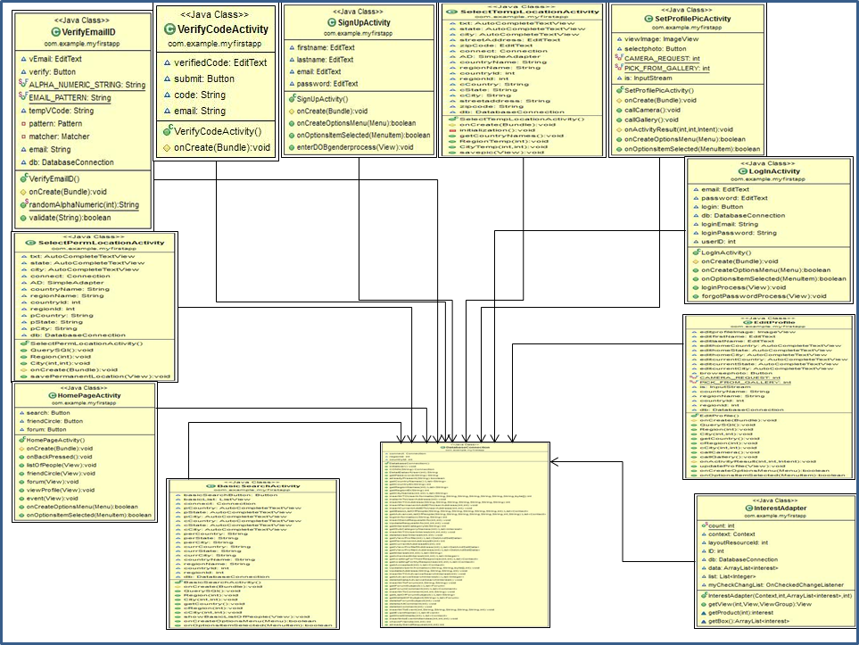

Figure 19: Class Diagram with Attributes and Operations

## Class Table

Table 4: Table of Classes

|  |  |  |  |
| --- | --- | --- | --- |
| **No.** | **Class Name** | **Class (Attributes and Functions)** | **Purpose** |
| **1.** | VerifyEmailID | \\NEELAM-PC\Users\Neelam\Desktop\Project Images\Class Diagram\VerifyEmailID.jpg | Sends email to your email id with the verification code. |
| **2.** | VerifyCodeActivity | D:\Project\MyFirstApp\myclassDiagram.jpg | Checks if the users enters code and send verification code is equal or not. |
| **3.** | SignUpActivity | D:\Project\MyFirstApp\myclassDiagram.jpg | Get data which user has entered and stored into database. |
| **4.** | SelectPremLocationActivity | D:\Project\MyFirstApp\myclassDiagram.jpg | Select the permanent country, state, and city. |
| **5.** | SelectTempLocationActivity | D:\Project\MyFirstApp\myclassDiagram.jpg | Select the current country, state, and city. And enter address and zipcode. |
| **6.** | SetProfilePicActivity | D:\Project\MyFirstApp\myclassDiagram.jpg | Select picture from the gallery or can click form the camera and set as the profile picture. And all other information is stored on to database |
| **7.** | LogInActivity | D:\Project\MyFirstApp\myclassDiagram.jpg | Login to app by username and password. |
| **8.** | HomePageActivity | D:\Project\MyFirstApp\myclassDiagram.jpg | After signup or login this activity will display all functionality form the app |
| **9.** | OnlyViewAndEditProfile | D:\Project\MyFirstApp\myclassDiagram.jpg | All information related to the user is shown in un editable mode. |
| **10.** | EditProfile | D:\Project\MyFirstApp\myclassDiagram.jpg | User can change or update the profile information. Also can change the profile picture. |
| **11.** | Interest | D:\Project\MyFirstApp\myclassDiagram.jpg | Getter and Setter class for interest information. |
| **12.** | InterestAdapter | D:\Project\MyFirstApp\myclassDiagram.jpg | Displays sub interest according to interest category. This class is used with two or more classes. |
| **13.** | EditAdvanceProfile | D:\Project\MyFirstApp\myclassDiagram.jpg | Shows list of interest with the checkbox selection of a particular category. Selected checkbox information is stored in to database |
| **14.** | BasicSearchActivity | D:\Project\MyFirstApp\myclassDiagram.jpg | Users can select Hometown country, state, city and Current country, state, city and get list of people on this basic search. |
| **15.** | AdvanceSearchActivity | D:\Project\MyFirstApp\myclassDiagram.jpg | Users can select Hometown country, state, city and Current country, state, city and different interest category, and get list of people on this advance search. |
| **16.** | ImageAdapter | D:\Project\MyFirstApp\myclassDiagram.jpg | Display information of particular person with the profile picture. |
| **17.** | ListOFAccepted | D:\Project\MyFirstApp\myclassDiagram.jpg | Displays list of people who have accepted friend requeste. |
| **18.** | ListOfWaitingForMyResponse | D:\Project\MyFirstApp\myclassDiagram.jpg | Displays list of people who have send user friend request. |
| **19.** | ListOFWaitingForTheirResponse | D:\Project\MyFirstApp\myclassDiagram.jpg | Displays list of people who user send friend request. |
| **20.** | PostForumActivity | D:\Project\MyFirstApp\myclassDiagram.jpg | User can enter subject and body. And able to post Forum. |
| **21.** | ViewForumActivity | D:\Project\MyFirstApp\myclassDiagram.jpg | User can view the forum, which was previously post by other user and even user can write the comment. |
| **22.** | SearchForumActivity | D:\Project\MyFirstApp\myclassDiagram.jpg | User can search a forum, by subject, from database. |
| **23.** | CreateEventActivity | D:\Project\MyFirstApp\myclassDiagram.jpg | User can create event and post as public or private. |
| **24.** | ViewEventActivity | D:\Project\MyFirstApp\myclassDiagram.jpg | User can see list of event and decide to go or not, by selecting Yes, No, May Be |

# SECTION 8

# SEQUENCE DIAGRAM

The following sequence diagrams (For Behavioral Model) show some of the core function performed by the user and system.

## 8.1 Sign Up and Log in



Figure 20: Sequence Diagram: Sign Up and Login

# SECTION 9

# DATA DESIGN

## Data flow Diagrams

A Level 0 Data Flow Diagram of inter connect-social application is shown in figure 21. The primary external entities are users (Register) and database. The data flow diagram at the system level illustrates the context (level 0) diagram. This diagram contains only a single, circle to represent the entire system.

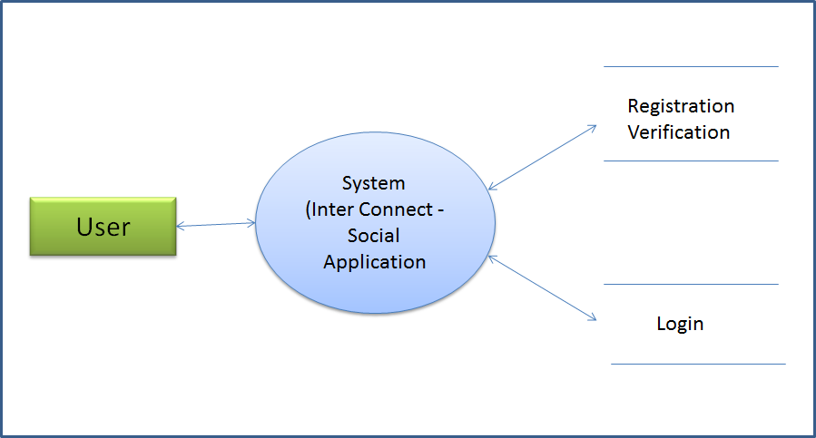

Figure 21: Context (Level 0) Diagram: Login and Registration by user

Level 1 Data Flow Diagram for login and registration is shown in figure 22. Level 1 DFD is expanded from level 0 DFD. The system is splits into four more processes for login and registration activity. The processes are Generate verification code & send email, Process sign up, process registration information, login Process. Level 1 shows complete flow of the data between processes and how each process uses and passes data to other process.

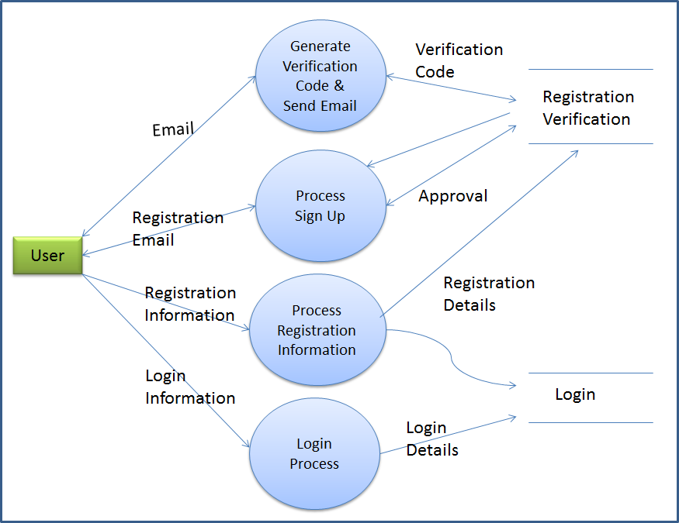

Figure 22: Level 1 Data Flow Diagram: Login and Registration by User

## Database Diagram

Database diagram is a diagram to display relationship of DB tables [6]. The Inter Connect-Social application has used 18DB tables; and relationships between some DB tables have been explained in figure 23.



Figure 23: Database Diagram of Inter Connect-Social Application

# SECTION 10

# SCREEN SHOTS AND CODE SNIPPET

1. Login Screen: Once user opens the application icon, user will be on Main screen shown below. From Main screen user click on login button goes to Login screen. On login screen, user needs to enter ‘User ID’ and ‘Password’.

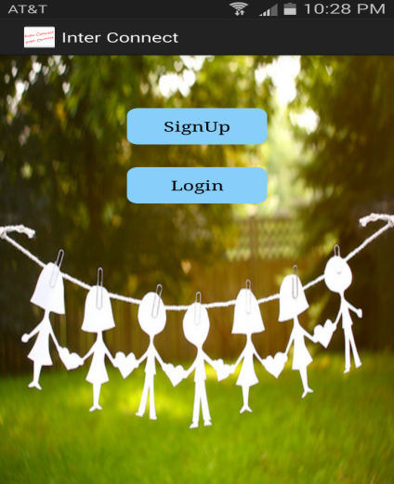 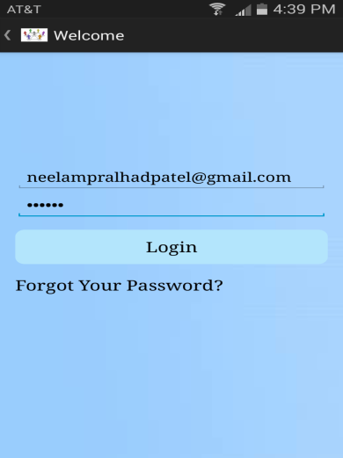

**Code Snippet:**

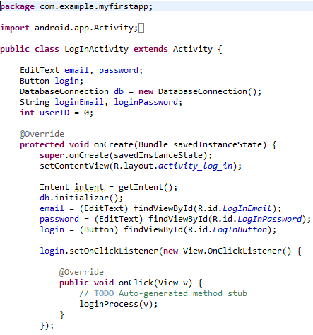

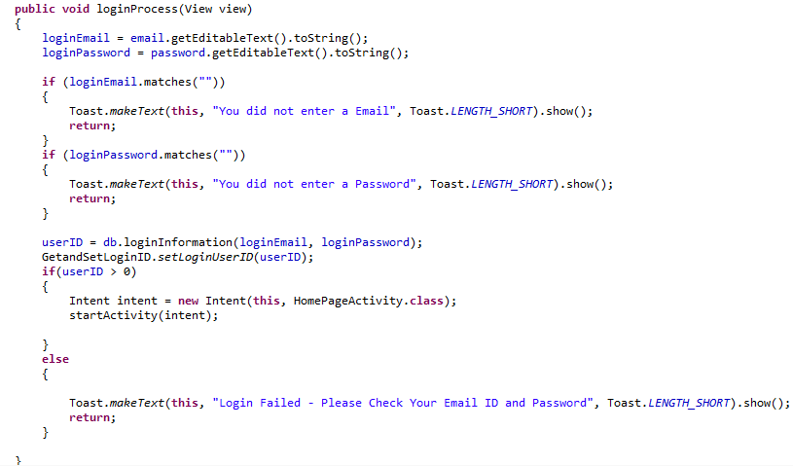

1. Home Screen:From home screen, user can access all the related functions or screens of the application. Also, users can logout from this screen by pressing back button of phone.

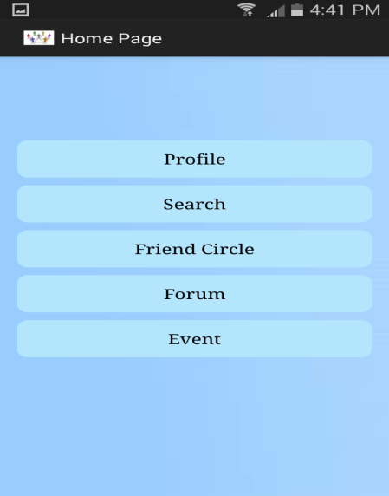

**Code Snippet:**

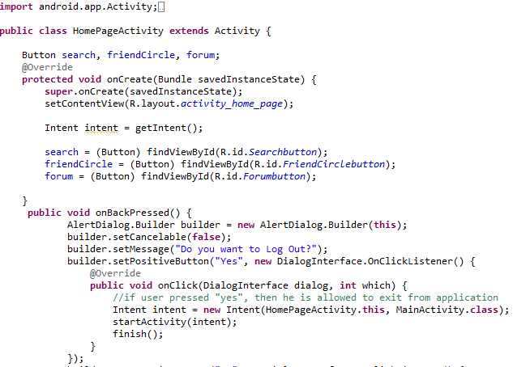

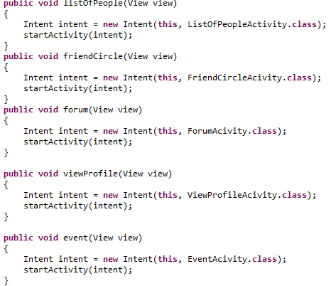

1. View Profile: On view profile screen, user can view his/her personal information show in below screen, user can insert a picture. Also, user can accress edit profile screen from view profile screen.

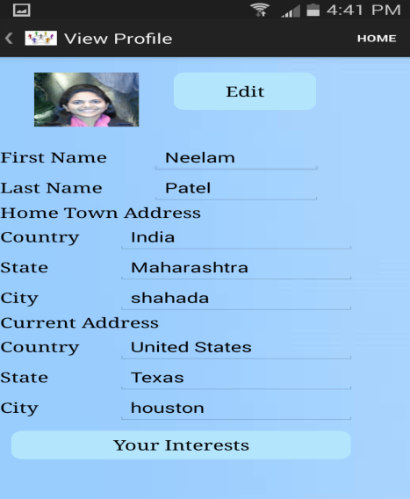 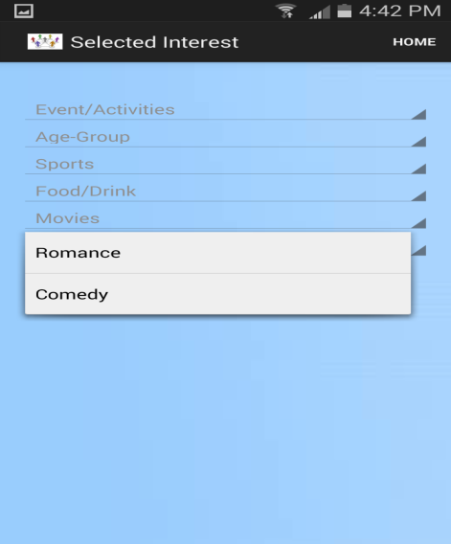

**Code Snippet:**

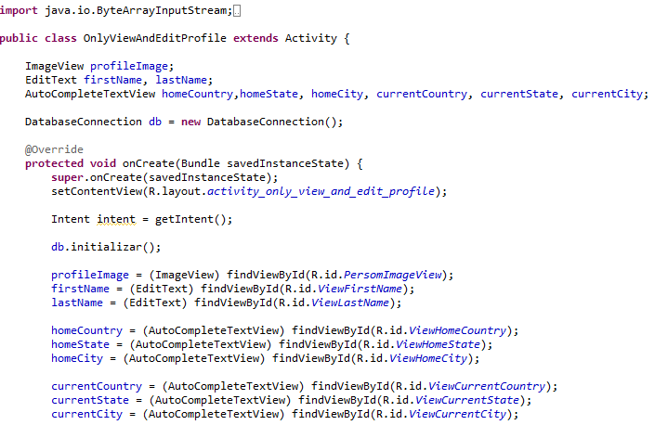

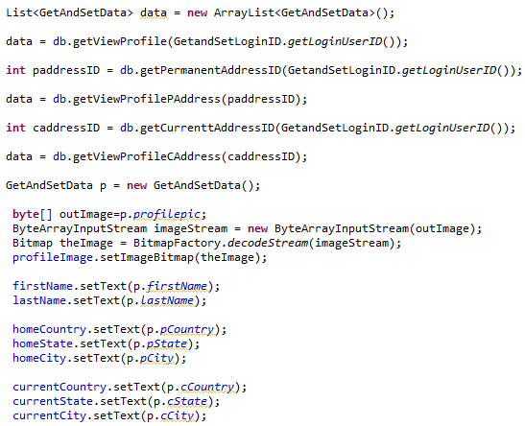

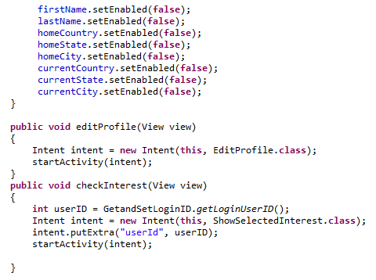

1. Search list of people: On search screen, user has to select search criteria, according to that user will enter proper data and database will send list of people.

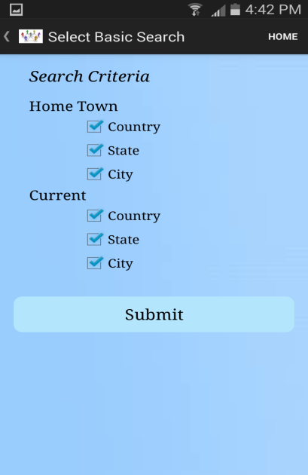 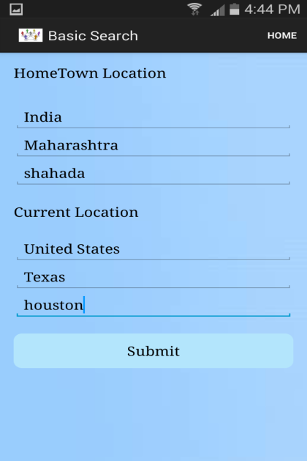 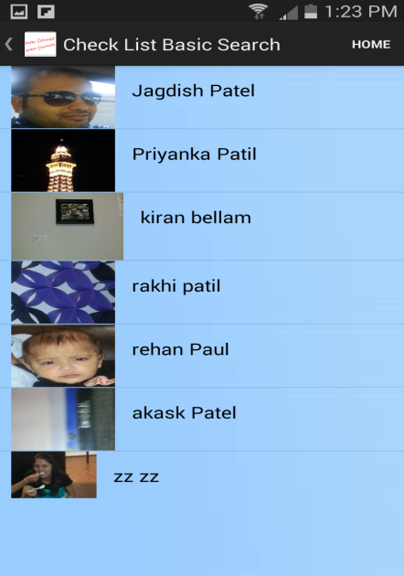

**Code Snippet:**

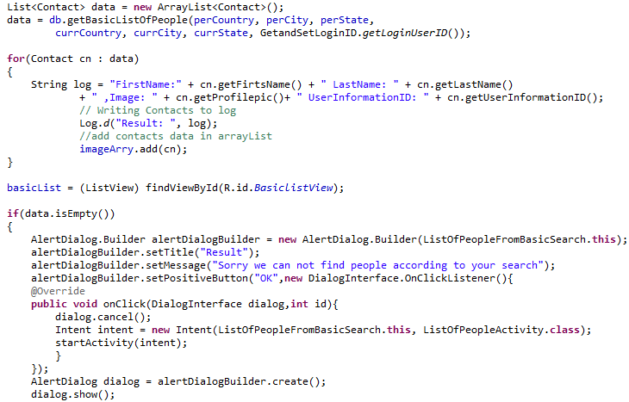

1. Detail Information of User screen: If the user click one of the people from the list, this screen is display. On this screen user can send the request to the other person by checking the interest.

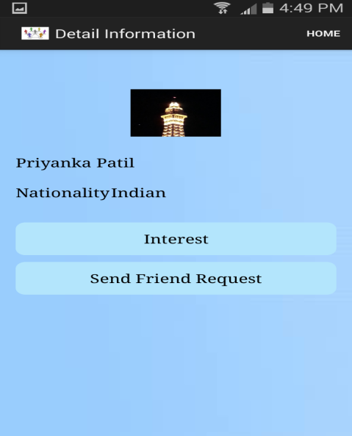

**Code Snippet:**

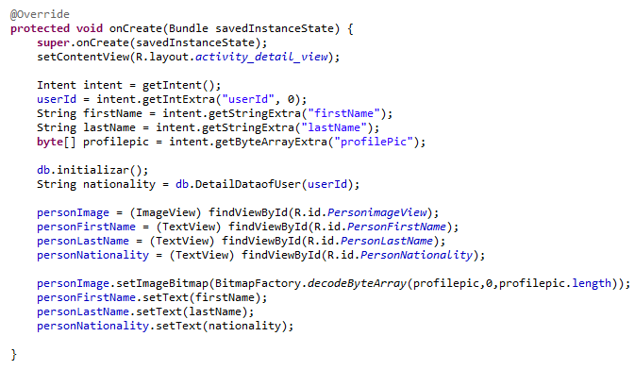

1. Friend Circle Screen**:** On this screen it will show the list of people accepted the friend request and people waiting for your response and list of people you are waiting for their response.

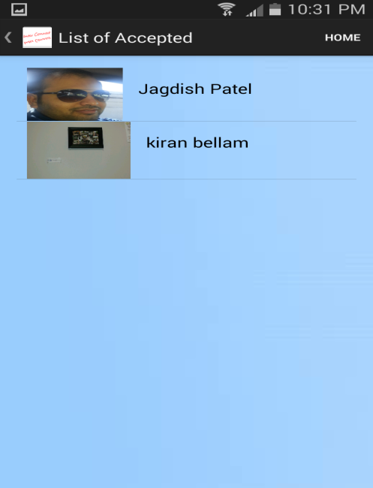 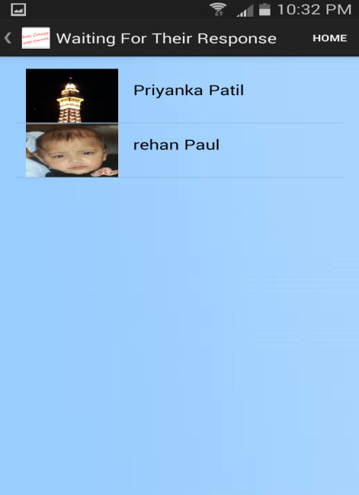

**Code Snippet:**

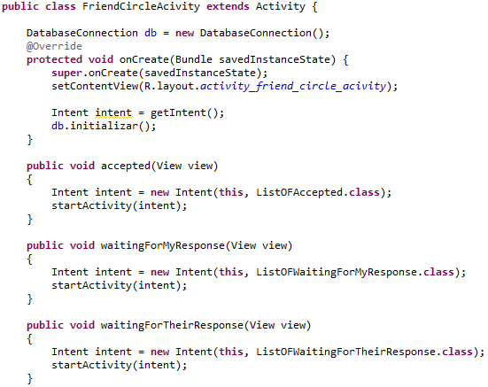

1. Post Forum screen**:** User can post the forum by entering subject and body.

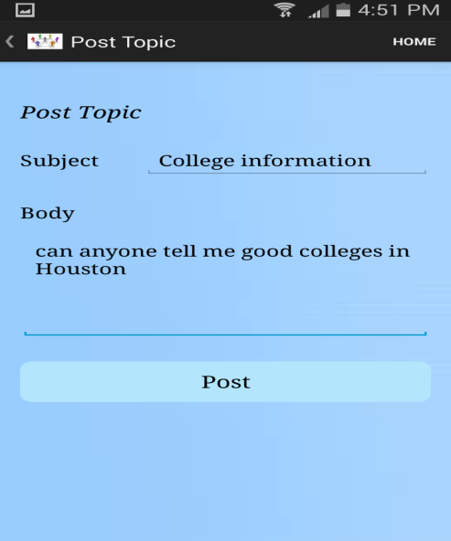

**Code Snippet:**

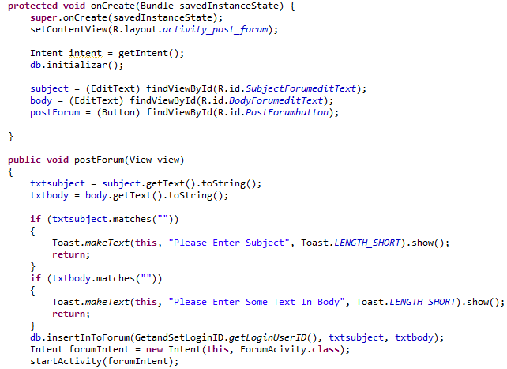

1. View Forum screen**:** on this screen user will able to see all posted forum.

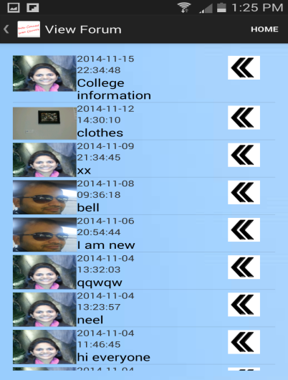 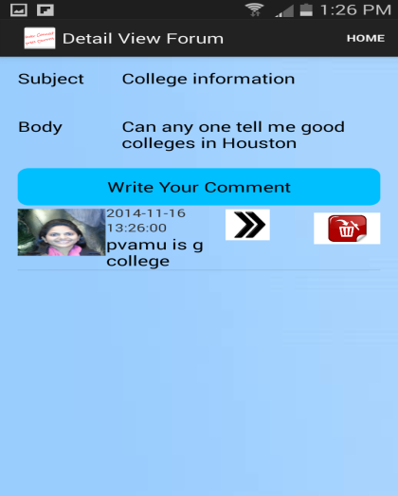

**Code Snippet:**

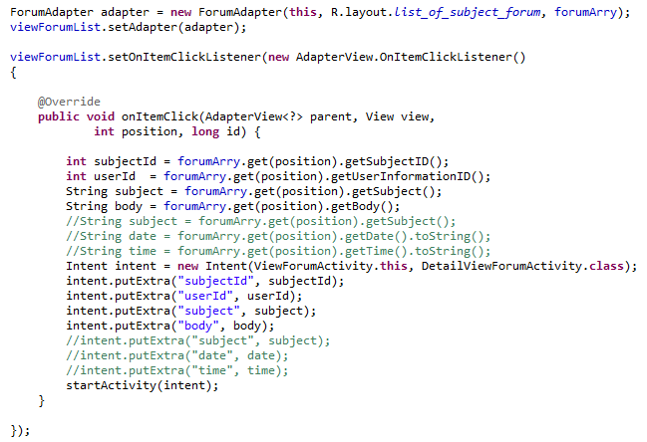

1. Create Event: On this screen user can create the event and post as public or private.

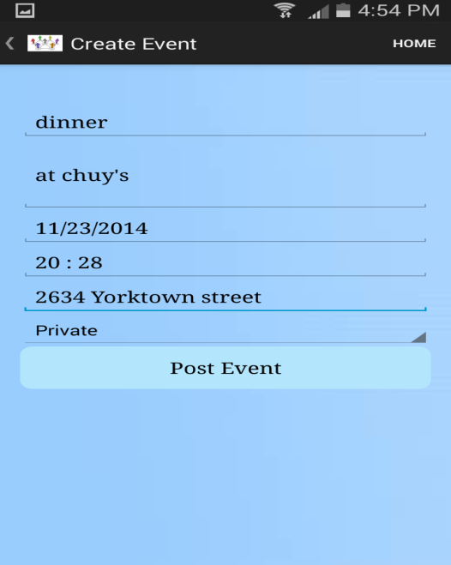

**Code Snippet:**

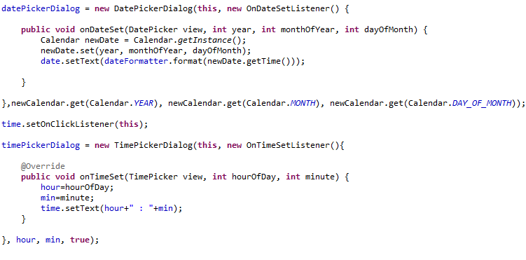

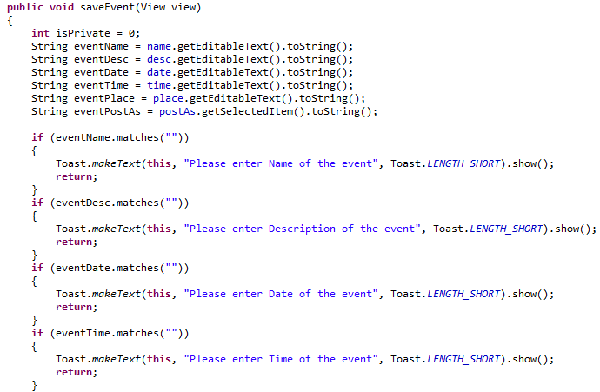

1. View Event: User can view the event which has been created by other user.

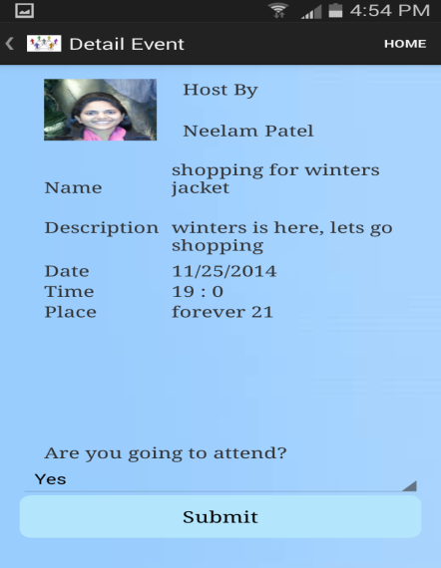

**Code Snippet:**

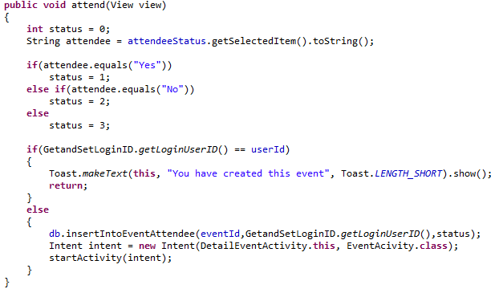

# SECTION 11

# TESTING

Software testing is an investigation conducted to provide client with information about the quality of the product or service under test. Unit and integration tests concentrate on functional verification of a component and incorporation of components into the software architecture. System testing is validates software once it has been incorporated into a larger system. Test strategy and preliminary test case specification are presented in this section [7].

## **Classes of Tests**

* **Unit Testing:**
* User validation test
* User Input event recognition test
* Display results
* Retrieving data and results from the memory test
* Binding data to UI test
* **Integration Testing:**
* Removing data from memory test.
* Storing data into memory test.
* Updating (Edit) data test.
* **System Testing:**
* Orientation support test.
* Installation and un-installation of the app into device test.
* Network availability test.
* Internet availability test.
* Initial Response time test.

## **Expected software response**

* Navigation test: App should navigate back and forth to different pages.
* User Input event recognition test: App should notify respective event based on user input.
* Display data from database: Application should display person information and also able to store updated data into database, which is delivered by executing different functionalities of application.
* Binding data to UI test: Data displayed on the UI is as per data parsed.

## **Performance Bounds**

* This system must be installed on android powered device.
* There are some performance issues for retrieve webpage. If system server is busy or cannot communicate with server, a component cannot retrieve the ride information from the other web resources.
* Device must have internet access in order to share post forum information, event creating information.

# SECTION 12

# CONCLUSION & FUTURE WORK

Inter Connect-Social Application is very effective means to let user search the people, and hangout with the friends. It is an application aimed to become friends with the stranger. People are identified with the pre-registration of the email ID before signup. Working with this project helped to learn more about Android SDK in JAVA language with MySQL database as backend tool. The Inter Connect-Social application has been successfully installed on current Android phone. Lack of some features in Inter Connect-Social application helps to think in a different direction about future work. After implementing the Inter Connect-Social application for Android phones, application can be enhanced with more functionality, by adding more screens.

# SECTION 13

# REFERENCES

[1] N. Hari Krishna and B.S.S.Prasad.C “Android Architecture,” Dept. CSE, PSCMR Collage of Engg.& Tech,10KT1A0565, <http://www.slideshare.net/kittu565/android-architecture>

[2] Li Ma and Lei Gu “Research and Development of Mobile Application for Android Platform,”

Vol.9, No.4, 2014.

[3] [Online]. Available: http://www.functionx.com/sqlserver/Lesson01.htm

[4] [Online]. Available:http://msdn.microsoft.com/en-us/library/aa214422%28v=sql.80%29.aspx

[5] [Online].Available: http://msdn.microsoft.com/en-us/library/aa174522%28v=sql.80%29.aspx

[6]Creation of Database Schema [Online]. Available: <http://www.isqa.unomaha.edu/wolcott/tutorials/erwin/dbschema.html>

[7] Roger S. Pressman, R.S. Pressman and Associates, “Software Engineering: A Practitioner’s Approach, 7/e”, Seventh edition, pp-31-212, ISBN: 0073375977, 2010.

[8] [5 Main Benefits of Social Mobile Event Apps](https://attendify.com/blog/5-main-benefits-of-social-mobile-event-apps/), [Online]. Available: https://attendify.com/blog/5-main-benefits-of-social-mobile-event-apps/

[9] Getting Started with the SQL Server JDBC Drive, [Online]. Available: <http://blogs.msdn.com/b/brian_swan/archive/2011/03/02/getting-started-with-the-sql-server-jdbc-driver.aspx>

[10] [How to save a photo in android database as a blob](http://stackoverflow.com/questions/17191097/how-to-save-a-photo-in-android-database-as-a-blob), [Online]. Available: <http://stackoverflow.com/questions/17191097/how-to-save-a-photo-in-android-database-as-a-blob>

[11] Sending Emails without User Intervention (no Intents) in Android, [Online]. Available: http://www.jondev.net/articles/Sending_Emails_without_User_Intervention_%28no_Intents%29_in_Android

[12] Converting a List into comma separated value string in Java, [Online]. Available: http://blog.sanaulla.info/2013/05/07/converting-a-list-into-comma-separated-value-string-in-java/

[13] Custom ListView with sliding view for each list, [Online]. Available: <http://android-coding-tuts.blogspot.in/2012/02/custom-listview-with-sliding-view-for.html>

[14] Working with ListView in Android. Customize ListView, Add item via a Button Click. And also clickable each button in each row, [Online]. Available: http://androidzoo.wordpress.com/2011/10/28/working-with-listview-in-android-customize-listview-add-item-via-a-button-click-and-also-clickable-each-button-in-each-row/